Application

Microcontroller

UART

DIO

MCAL

* APP APIs

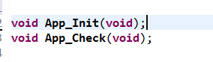

* UART APIs

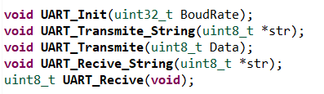

* DIO APIs

